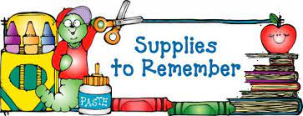

Second Grade

* 3 Prong Poly (Plastic) pocket folders: blue, green, yellow
* 2 Composition notebooks
* 2 Boxes of 24 count Crayons
* 1 pack of Expo Dry Erase Markers Ultra Fine Tip
* 1 pair of Blunt Tip Scissors
* 1 pack of Pink Pearl Erasers
* 1 pencil box or pouch
* Pair of headphones (No earbuds please)
* Book Bag (No rolling book bags please)

**Communally Supplies**

* 2 packs of wide ruled filler paper
* 2 Packs of 24 pencils
* 1 pack of colored pencils

**Wish List**

* Ziploc bags (gallon)
* Pack of sheet protectors
* Index Cards
* Box of Tissue
* Bottle of Hand Soap
* 2 bottles of Hand Sanitizer
* 2 canisters of wipes disinfecting wipes